EWMA correlation: EURUSD and GBPUSD
Method 06 / daily log returns / lambda = 0.94 / Alpari D1 full available history

Study setup
Logical pair: EURUSD , GBPUSD
Broker symbols: EURUSD_i , GBPUSD_i
Snapshot: 2026-11-03_majors_alpari_D1
Timeframe: D1
Matched return window: 1999-01-05 to 2026-11-02 (UTC bar dates)
Matched return count n: 7202
Dropped unfinished last bar dated 2026-11-03 UTC after a tick-volume check against the prior complete day.
Lambda: 0.94 (today weight 0.06)
Burn-in ignored in path summaries and chart: first 60 updates
Mean adjustment: each leg demeaned by its mean on the matched rows
Seeds: c_0 = v_x,0 = v_y,0 = 0
Complete matched rows (Excel): EURUSD-GBPUSD_EWMA_D1.xlsx
Complete matched rows (HTML table): EURUSD-GBPUSD_EWMA_D1_data.html

Method carried forward
EWMA correlation updates covariance and variances of mean-adjusted daily log returns of close, ln(close_t / close_t-1), with lambda = 0.94 (6% weight on today's product or square, 94% on yesterday's EWMA state). Quotes are not inverted. Each leg is demeaned by its mean on the matched rows; that mean uses the full sample, so the rho path is a full-sample description, not a live filter. Seeds start at zero. Path summaries and the chart ignore the first 60 updates so the zero seed has faded. The headline is rho on the last day. rho is symmetric under swap of the two symbols. A high |rho| does not prove cause, lead-lag, or a trading signal. Today's return sits inside today's rho, so the estimate can only inform a later decision. Same-sample Pearson r is a side check only.

Results
Latest EWMA rho: 0.852473
Post-burn-in path (n=7142): mean=0.658094, median=0.686043, min=-0.182133, max=0.943938, std=0.166113
Share of post-burn-in days with |rho| >= 0.4: 92.82%; |rho| >= 0.7: 46.91%
Same-sample Pearson r: 0.641738
Latest rho minus r: 0.210735

Conclusion
Over 7202 matched daily log-return rows for EURUSD and GBPUSD (broker quote directions unchanged), latest EWMA rho with lambda=0.94 is 0.8525 (positive, strong recent linear link in this sample). After a 60-day burn-in, path mean is 0.6581, std is 0.1661, and the range is [-0.1821, 0.9439]. Same-sample Pearson r is 0.6417 (latest rho minus r = 0.2107). This does not establish cause, lead-lag, or a lasting trading rule.

Charts
Daily closes

Daily log returns
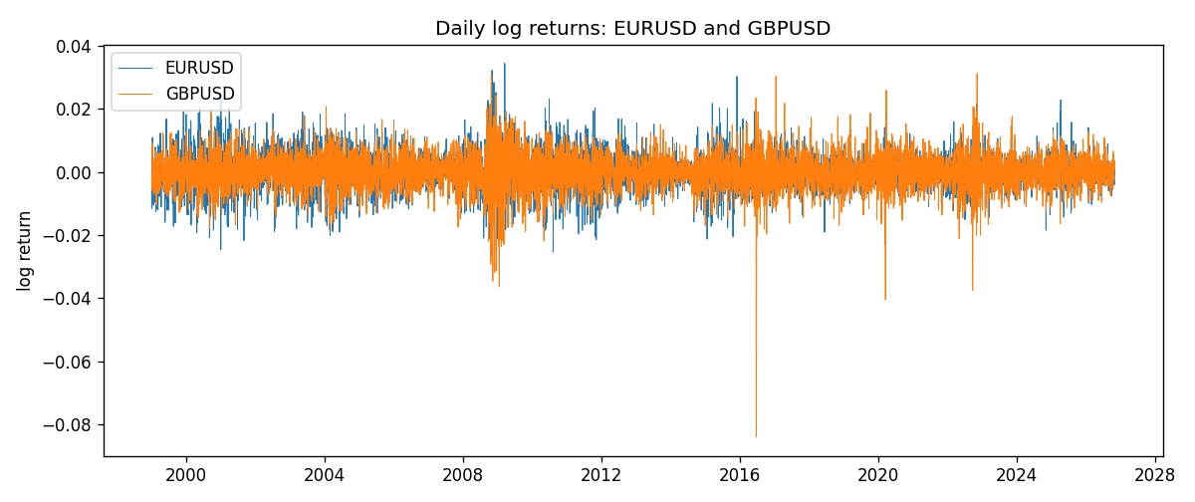
EWMA rho path with Pearson r reference
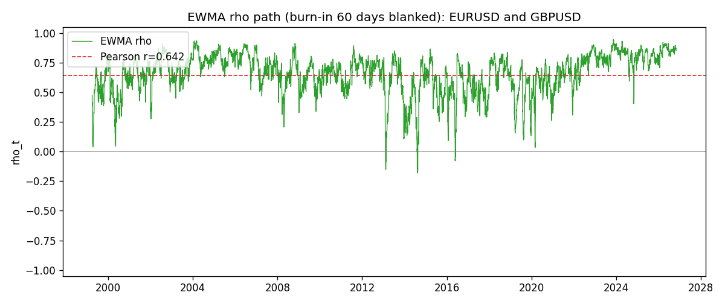

Data report
Every matched row that entered the EWMA recursion is stored in the sibling Excel workbook named EURUSD-GBPUSD_EWMA_D1.xlsx. That file is the complete data archive for redrawing charts. Embedding all rows as a Word table is impractical at this length; the Word file holds the column list, column summaries, and the first and last 15 matched rows.
Columns: time, EURUSD_open, GBPUSD_open, EURUSD_high, GBPUSD_high, EURUSD_low, GBPUSD_low, EURUSD_close, GBPUSD_close, EURUSD_tick_volume, GBPUSD_tick_volume, EURUSD_spread, GBPUSD_spread, EURUSD_real_volume, GBPUSD_real_volume, EURUSD_log_return, GBPUSD_log_return, EURUSD_x_demeaned, GBPUSD_y_demeaned, c_t, v_x, v_y, rho_t
Column summaries (matched calculation rows)
column | count | mean | std | min | 25% | 50% | 75% | max
EURUSD_open | 7202 | 1.1812936 | 0.15087968 | 0.8272 | 1.086065 | 1.166145 | 1.293925 | 1.5995
GBPUSD_open | 7202 | 1.5160822 | 0.2182507 | 1.06854 | 1.325005 | 1.51141 | 1.63166 | 2.1066
EURUSD_high | 7202 | 1.1864255 | 0.15147858 | 0.8326 | 1.0901775 | 1.17127 | 1.2992275 | 1.6038
GBPUSD_high | 7202 | 1.5223773 | 0.21881719 | 1.08366 | 1.329795 | 1.51815 | 1.63839 | 2.1161
EURUSD_low | 7202 | 1.1762813 | 0.15020267 | 0.8227 | 1.0819975 | 1.162535 | 1.288315 | 1.5865
GBPUSD_low | 7202 | 1.5097565 | 0.21747799 | 1.03518 | 1.3195075 | 1.503295 | 1.6243825 | 2.0983
EURUSD_close | 7202 | 1.1813323 | 0.15085599 | 0.8267 | 1.0860025 | 1.166105 | 1.2939475 | 1.5997
GBPUSD_close | 7202 | 1.5161468 | 0.21820921 | 1.06879 | 1.325125 | 1.511325 | 1.632095 | 2.1065
EURUSD_tick_volume | 7202 | 102990.53 | 173401.83 | 218 | 9388.25 | 52708 | 99433.75 | 1471626
GBPUSD_tick_volume | 7202 | 94813.509 | 153540.37 | 62 | 9988.5 | 52886.5 | 91789.25 | 1273370
EURUSD_spread | 7202 | 19.400444 | 16.577153 | 0 | 8 | 12 | 30 | 50
GBPUSD_spread | 7202 | 26.974313 | 19.194125 | 0 | 11 | 20 | 50 | 50
EURUSD_real_volume | 7202 | 4.0233049e+10 | 1.6674277e+11 | 0 | 0 | 0 | 0 | 3.6149665e+12
GBPUSD_real_volume | 7202 | 3.5555961e+09 | 8.4432361e+10 | 0 | 0 | 0 | 0 | 2.4038164e+12
EURUSD_log_return | 7202 | -7.71e-06 | 0.00580133 | -0.03123819 | -0.00324586 | 0 | 0.00325471 | 0.03433183
GBPUSD_log_return | 7202 | -2.587e-05 | 0.00564523 | -0.08388241 | -0.00313091 | 3.124e-05 | 0.00317757 | 0.03112653
EURUSD_x_demeaned | 7202 | -0 | 0.00580133 | -0.03123047 | -0.00323815 | 7.71e-06 | 0.00326243 | 0.03433954
GBPUSD_y_demeaned | 7202 | 0 | 0.00564523 | -0.08385654 | -0.00310504 | 5.711e-05 | 0.00320344 | 0.0311524
c_t | 7202 | 2.1e-05 | 1.893e-05 | -3.74e-06 | 1.091e-05 | 1.662e-05 | 2.475e-05 | 0.00021825
v_x | 7202 | 3.363e-05 | 2.629e-05 | 1.4e-06 | 1.665e-05 | 2.758e-05 | 4.241e-05 | 0.00025677
v_y | 7202 | 3.184e-05 | 3.403e-05 | 4.8e-07 | 1.748e-05 | 2.39e-05 | 3.343e-05 | 0.00052542
rho_t | 7202 | 0.65777286 | 0.16599788 | -0.18213304 | 0.57049998 | 0.68584044 | 0.77710614 | 1
First 15 matched rows (selected columns)
time | EURUSD_close | GBPUSD_close | EURUSD_log_return | GBPUSD_log_return | EURUSD_x_demeaned | GBPUSD_y_demeaned | c_t | v_x | v_y | rho_t
1999-01-05 | 1.1758 | 1.6547 | -0.0048360507 | -0.0028966287 | -0.0048283381 | -0.0028707597 | 8.3165993e-07 | 1.398771e-06 | 4.9447569e-07 | 1
1999-01-06 | 1.1623 | 1.6537 | -0.011547966 | -0.00060452184 | -0.011540254 | -0.00057865293 | 1.1824284e-06 | 9.3054922e-06 | 4.848975e-07 | 0.55664744
1999-01-07 | 1.1712 | 1.6502 | 0.0076280636 | -0.002118709 | 0.0076357761 | -0.0020928401 | 1.5265523e-07 | 1.2245467e-05 | 7.1860243e-07 | 0.051461173
1999-01-08 | 1.1585 | 1.6405 | -0.010902799 | -0.0058954193 | -0.010895087 | -0.0058695504 | 3.9804516e-06 | 1.8632914e-05 | 2.7425836e-06 | 0.5568164
1999-01-11 | 1.1503 | 1.6312 | -0.007103287 | -0.0056851331 | -0.0070955744 | -0.0056592642 | 6.1509683e-06 | 2.053577e-05 | 4.4996648e-06 | 0.63987908
1999-01-12 | 1.1555 | 1.6349 | 0.0045103728 | 0.0022657001 | 0.0045180853 | 0.002291569 | 6.4031205e-06 | 2.0528409e-05 | 4.5447623e-06 | 0.6629159
1999-01-13 | 1.1681 | 1.6499 | 0.010845346 | 0.0091330396 | 0.010853059 | 0.0091589085 | 1.1983064e-05 | 2.6364038e-05 | 9.3052129e-06 | 0.76506572
1999-01-14 | 1.1681 | 1.6531 | 0 | 0.0019376331 | 7.712521e-06 | 0.001963502 | 1.1264988e-05 | 2.4782199e-05 | 8.9782205e-06 | 0.75520646
1999-01-15 | 1.1563 | 1.6502 | -0.010153245 | -0.0017558204 | -0.010145533 | -0.0017299515 | 1.1642166e-05 | 2.9471177e-05 | 8.6190912e-06 | 0.73047323
1999-01-18 | 1.1605 | 1.6522 | 0.0036256946 | 0.0012112405 | 0.0036334071 | 0.0012371094 | 1.1213331e-05 | 2.8495005e-05 | 8.1937721e-06 | 0.73385176
1999-01-19 | 1.1603 | 1.6553 | -0.00017235436 | 0.0018745281 | -0.00016464184 | 0.0019003971 | 1.0521758e-05 | 2.6786932e-05 | 7.9188363e-06 | 0.72243064
1999-01-20 | 1.1566 | 1.6472 | -0.0031939256 | -0.0049053846 | -0.0031862131 | -0.0048795156 | 1.0823283e-05 | 2.5788833e-05 | 8.8722865e-06 | 0.71552598
1999-01-21 | 1.1601 | 1.6524 | 0.0030215416 | 0.0031518998 | 0.0030292541 | 0.0031777687 | 1.0751463e-05 | 2.4792086e-05 | 8.9458422e-06 | 0.72193882
1999-01-22 | 1.1587 | 1.6565 | -0.0012075213 | 0.0024781662 | -0.0011998088 | 0.0025040351 | 9.926113e-06 | 2.3390933e-05 | 8.7853031e-06 | 0.6924319
1999-01-25 | 1.1552 | 1.6585 | -0.0030251979 | 0.0012066366 | -0.0030174853 | 0.0012325056 | 9.1074022e-06 | 2.253379e-05 | 8.3493291e-06 | 0.66397481
Last 15 matched rows (selected columns)
time | EURUSD_close | GBPUSD_close | EURUSD_log_return | GBPUSD_log_return | EURUSD_x_demeaned | GBPUSD_y_demeaned | c_t | v_x | v_y | rho_t
2026-10-13 | 1.11965 | 1.32534 | 0.0037402957 | 0.0036434319 | 0.0037480082 | 0.0036693008 | 8.6936871e-06 | 1.0566733e-05 | 9.4672139e-06 | 0.86920566
2026-10-14 | 1.11545 | 1.31884 | -0.0037582255 | -0.0049164679 | -0.003750513 | -0.004890599 | 9.2726012e-06 | 1.077671e-05 | 1.0334259e-05 | 0.8786559
2026-10-15 | 1.12172 | 1.32757 | 0.0056053107 | 0.0065976411 | 0.0056130232 | 0.00662351 | 1.094692e-05 | 1.2020469e-05 | 1.2346456e-05 | 0.8985869
2026-10-16 | 1.12371 | 1.33257 | 0.0017724895 | 0.0037592051 | 0.001780202 | 0.003785074 | 1.0694397e-05 | 1.1489388e-05 | 1.2465276e-05 | 0.89362826
2026-10-19 | 1.12086 | 1.33024 | -0.0025394633 | -0.0017500314 | -0.0025317507 | -0.0017241625 | 1.0314642e-05 | 1.118461e-05 | 1.1895724e-05 | 0.89422805
2026-10-20 | 1.12354 | 1.3377 | 0.0023881672 | 0.0055923442 | 0.0023958798 | 0.0056182132 | 1.0503397e-05 | 1.0857948e-05 | 1.3075839e-05 | 0.88149756
2026-10-21 | 1.12318 | 1.33937 | -0.00032046717 | 0.0012476328 | -0.00031275465 | 0.0012735018 | 9.8492957e-06 | 1.021234e-05 | 1.2388597e-05 | 0.87565185
2026-10-22 | 1.12139 | 1.33967 | -0.0015949606 | 0.00022396082 | -0.0015872481 | 0.00024982974 | 9.2345454e-06 | 9.7507612e-06 | 1.1649026e-05 | 0.86646584
2026-10-23 | 1.11989 | 1.33684 | -0.001338521 | -0.0021146949 | -0.0013308085 | -0.002088826 | 8.8472623e-06 | 9.2719786e-06 | 1.1211876e-05 | 0.86772786
2026-10-26 | 1.11735 | 1.33359 | -0.0022706559 | -0.0024340661 | -0.0022629434 | -0.0024081972 | 8.6434034e-06 | 9.0229146e-06 | 1.0887129e-05 | 0.8720767
2026-10-27 | 1.11272 | 1.33044 | -0.004152342 | -0.0023648393 | -0.0041446295 | -0.0023389704 | 8.7064492e-06 | 9.512217e-06 | 1.0562148e-05 | 0.8686085
2026-10-28 | 1.1152 | 1.33254 | 0.0022262927 | 0.0015771808 | 0.0022340052 | 0.0016030497 | 8.3989355e-06 | 9.2409307e-06 | 1.0082605e-05 | 0.87012172
2026-10-29 | 1.11772 | 1.33733 | 0.0022571351 | 0.0035881935 | 0.0022648476 | 0.0036140625 | 8.3861174e-06 | 8.9942469e-06 | 1.0261336e-05 | 0.87292431
2026-10-30 | 1.11644 | 1.33913 | -0.0011458446 | 0.0013450605 | -0.0011381321 | 0.0013709294 | 7.7893324e-06 | 8.5323128e-06 | 9.7584224e-06 | 0.85364451
2026-11-02 | 1.11881 | 1.3406 | 0.002120569 | 0.0010971256 | 0.0021282815 | 0.0011229945 | 7.4653754e-06 | 8.292149e-06 | 9.248584e-06 | 0.8524727

